Harlem Renaissance

Web Quest 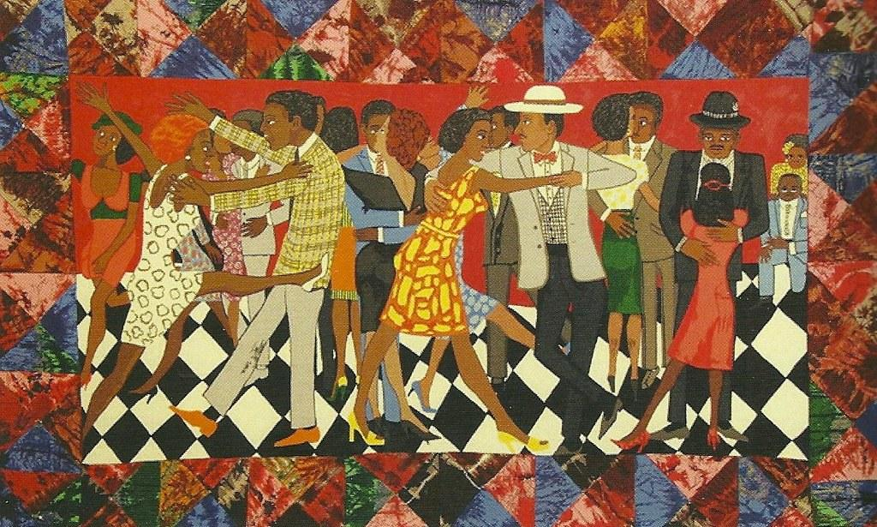

*Directions: click on the hyperlink to get to the web source to learn more about the Harlem Renaissance period. Then answer the questions as complete as you can.*

<https://www.history.com/topics/roaring-twenties/harlem-renaissance>

1. What time period did the Harlem Renaissance last?

The Harlem Renaissance lasted from 1910s to the mid 1930s.

1. What multifaceted events brought a very large influx of African Americans to this singular neighborhood in upper Manhattan?

*The multifaceted events that brought a very large influx of African Americans to this singular neighborhood in upper Manhattan were multiple events. One of these was a black family trying to be forced out by white families but the white families failed; Another was the rapid and oversight construction of buildings being overdeveloped causing the landlords panicking and needing to find people and trying to fill them.* ***Also, natural disasters in the South forced Blacks to move Northward.***

1. By 1920, how many African Americans had moved to Harlem?

***The amount of African Americans that had moved to Harlem in the 1920s were 300,000 African americans. Harlem was a very popular place for african americans who were moving from the south to the north Harlem being one of them.***

<https://www.britannica.com/event/Harlem-Renaissance-American-literature-and-art>

1. What mediums (ways of presenting information) did various artists use to present the new conceptualized “negro?”

***The various artists used like literary, history, visual arts, theatrical and culture to revisit “the negro apart” influencing stereotypes on them with white people also being involved. Also to influence African, Black, etc people’s relationships to their culture and heritage.***

1. What were participants of this cultural awakening trying to break free from?

***The participants of the cultural awakening were trying to break free from Victorian moral values and bourgeois shaming them to get rid of their characteristics and parts of their life changing it so white people don't reinstate racism on them.***

**BACKGROUND section**

1. How did the Harlem Renaissance period contribute to the later Civil Rights Movement of the 1940s onward?

***Harlem was a place that attracted all African Americans and black people which led in the 1940s for something known as the Great Migration from people traveling from the north to the south. Which they took on to contribute art, literature, culture and more. Also, The founding of National Organizations like the NAACP.***

<https://nmaahc.si.edu/explore/stories/new-african-american-identity-harlem-renaissance>

1. What significant event led African Americans to recognize their potential as participants into American society?

***The significant event that led to the African Americans to recognize their potential in American society was the Civil Rights Movement and also the Great Migration.***

1. What antagonists existed to put a stop to this new growth for African Americans?

***The antagonists who tried to stop the Civil Rights Movement were the KKK.***

1. What major metropolitan areas did African Americans move to during this Great Migration?

***The Major Metropolitan areas that the African Americans tried to move to in the Great Migration were to places like Chicago, New York, Philadelphia, Detroit and Los Angeles.***

1. What expression did Alain Locke use to characterize this great tectonic shift in population for African Americans? ***Alan Locke described it as the “spiritual coming of age.”***